**“LIBRARY MANAGEMENT SYSTEM”**

Real Time Research Project/Societal Related Project

Bachelor of technology in

COMPUTER SCIENCE AND ENGINEERING

BY

S. LALITHA SHIVAPRIYA - 22631A0523

M. KALYANI - 22631A0519

SK. AZRA - 22631A0506

J. ANUSHA - 22631A0503



**DEPARTMENT OF COMPUTER SCIENCE AND ENGINEERING**

**SRI VENKATESHWARA ENGINEERING COLLEGE**

(SPONSERED BY THE EXHIBITION SOCIETY, HYD)

(Affiliated to Jawaharlal Nehru Technological University, Hyderabad) SURYAPET,

SURYAPET (DIST), Telangana, India

June-2024

**DEPARTMENT OF COMPUTER SCIENCE AND ENGINEERING**

**SRI VENKATESHWARA ENGINEERING COLLEGE**

**SURYAPET-508213**



CERTIFICATE

This is to certify the project entitled “***LIBRARY MANAGEMENT SYSTEM***” is the bonafide work done by

S. LALITHA SHIVAPRIYA - 22631A0523

M. KALYANI - 22631A0519

SK. AZRA - 22631A0506

J. ANUSHA - 22631A0503

in partial fulfilment of the requirements for the award of ***Bachelor of Technology in Computer Science and Engineering*** by **JNTUH** during the academic year 2023-2024.

**Head of the Department**

Mr. P. Rathaiah

Sr. Assistant Professor

Depart. Of CSE

Sri Venkateshwara Engineering College,

Suryapet.

**Principal External Examiner**

Dr. Raju Muthyala M. Tech, PhD

Sri Venkateshwara Engineering

College, Suryapet.

**DECLARATION**

We, S. Lalitha shivapriya, M. Kalyani, SK. Azra, J. Anusha students of BTech with Computer Science and Engineering of Sri Venkateshwara Engineering college, Suryapet, being H.T. No 22631A0523, 22631A0519, 22631A0506, 22631A0503 respectively, hereby declare that the project with title “***LIBRARY MANAGEMENT SYSTEM*** ” is the original work done by us. To the best of our knowledge and belief, we hereby declare that this project bears no resemblance to any other project submitted at Sri Venkateswara Engineering College, Suryapet or any other college affiliated to Jawaharlal Nehru Technological University, Hyderabad for the award of the degree.

Place: **Suryapet**

Date: /06/2024

***Signature of the candidate***

S. Lalitha shivapriya M. Kalyani SK. Azra J. Anusha

**ACKNOWLEDGEMENT**

We express our profound gratitude to the Almighty for granting us the courage and perseverance to complete this project. This project stands as a testament to the contributions and support of many individuals who have played a vital role in its success.

We extend our heartfelt thanks to **Mr. P. Rathaiah**, Head of the Department of Computer Science and Engineering, **Dr. M. Raju**, Principal, and **Dr. D. Kiran Kumar**, Director of **S.V.E.S**, for providing excellent facilities, motivation, and encouragement, which were instrumental in the timely completion of this project.

We would also like to express our deep sense of gratitude to our parents for their moral support and heartfelt cooperation throughout the duration of this project. Additionally, we are grateful to all the teaching and non-teaching staff, as well as our friends, whose direct or indirect assistance has been invaluable in the successful completion of this work.

***Project Associate***

S. Lalitha shivapriya

M. Kalyani

SK. Azra

J. Anusha

**Table of Contents**

|  |  |
| --- | --- |
| **Contents** | **Page** |
| CERTIFICATE | 2 |
| DECLARATION | 3 |
| ACKNOWLEDGEMENT | 4 |
| ABSTRACT | 7 |
| CHAPTER 1 INTRODUCTION | 8 |
| PROJECT AIMS AND OBJECTIVES | 8 |
| BACKGROUND OF PROJECT | 8 |
| PROJECT AIMS AND OBJECTIVES | 8 |
| BACKGROUND OF PROJECT | 8 |
| CHAPTER 2 FEASIBILITY STUDY | 9 |
| CHAPTER 3 SYSTEM ANALYSIS | 10 |
| 3.1 EXISTING SYSTEM OF LMS (LIBRARY MANAGEMENT SYSTEM) | 10 |
| 3.2 PROPOSED SYSTEM OF LMS | 10 |
| CHAPTER 4 SYSTEM STUDY | 12 |
| 4.1.1 HARDWARE REQUIREMENTS | 12 |
| 4.1.2 SOFTWARE REQUIREMENTS | 12 |
| 4.2 LIBRARIES USED | 12 |
| 4.3 DATA FLOW | 12 |
| 4.4 REQUREMENT ANALYSIS | 13 |
| 4.4.1 FUNCTIONAL REQUIREMENTS | 13 |
| **4.4.2** NON-FUNCTIONAL REQUIREMENTS | 13 |
| CHAPTER 5 SYSTEM IMPLEMENTATION | 14 |
| CHAPTER 6 SYSTEM AND DATABASE ANALYSIS | 22 |
| CHAPTER 7 SYSTEM TESTING | 29 |
| CHAPTER 8 CONCLUSION AND FUTURE SCOPE OF PROJECT | 30 |
| CHAPTER 9 SYSTEM SECURITY | 33 |
| CHAPTER 10 REFERENCES | 34 |
| VOTE OF THANKS | 35 |

***Abstract***

**Overview:** A Library Management System(LMS)is a software solution designed to streamline library operations.

**Functions:** It encompasses cataloguing, circulation, patron management, and resource tracking functionalities.

**Cataloguing:** LMS facilitates the acquisition, organization, and classification of library materials.

**Circulation:** It manages the borrowing and returning of library items, ensuring efficient circulation processes.

**Patron Management:** LMS includes features for user authentication, privileges, and managing patron information.

**Resource Tracking:** It tracks the availability, location, and status of library resources, aiding in inventory management.

**Searchable Catalogue:** LMS provides a searchable catalogue for users to find and access library materials easily.

**Circulation** **Management Tools:** It offers tools for librarians to manage loan periods, fines, and reservations effectively.

**User Experience:** LMS enhances the accessibility and user experience by enabling patron store serve materials and track their borrowing history online.

**Efficiency:** By automating routine tasks, LMS reduces manual effort for librarians and improves over a l operational efficiency.

**Reporting:** LMS generates reports on library usage, circulation statistics, and inventory status, aiding in decision-making and resource allocation.

**Central Hub:** It serves as a central hub for library administration, promoting effective resource utilization and enhancing the quality of library services.

Overall, a library management system plays a crucial role in modernizing library operations, enhancing user experience, and promoting effective resource utilization in libraries of all types and sizes.

**CHAPTER 1**

**INTRODUCTION**

This chapter gives an overview about the aim, objectives, background and operation environment of the system.

The Library Management System (LMS) is a comprehensive software application designed to automate and streamline the operations of libraries. This project aims to create an efficient system for managing various library tasks such as acquisitions, cataloguing, member management, circulation, and inventory control. By implementing an LMS, libraries can enhance their organizational capabilities, improve resource management, and provide a user-friendly experience for both librarians and patrons.

**PROJECT AIMS AND OBJECTIVES**

The project aims and objectives that will be achieved after completion of this project are discussed in this subchapter. The aims and objectives are as follows:

* A student can login or create into his or her account
* Admin can log or create into his or her account
* Gives chance for admin to issue a book
* Allows to view number of books borrowed
* Allows to add new books to library
* Allows to delete old books from library

**BACKGROUND OF PROJECT**

A library management system (LMS) is a software platform designed to streamline the administrative tasks of libraries while enhancing user experience. It centralizes functions like cataloguing, circulation, and patron management, enabling efficient organization and access to resources. LMSs facilitate easy search and discovery of materials, allowing patrons to find items quickly. They also manage borrowing processes, tracking loan periods, holds, and fines. Additionally, LMSs provide librarians with valuable insights through reporting and analytics tools, aiding in decision-making for collection development and service improvements. Integration with other systems and customization options further optimize the system to meet the specific needs of different libraries. Overall, LMSs modernize library operations, promoting effective resource utilization and improving services for patrons.

**CHAPTER 2**

**Feasibility Study**

A feasibility study is an assessment of the practicality and viability of a proposed project, system, or solution. It aims to determine whether the proposed endeavour is technically feasible, economically viable, and operationally practical. Feasibility studies are conducted before undertaking a project to evaluate its potential for success and to help stakeholders make informed decisions about whether to proceed with the proposed initiative.

**TECHNICAL FEASIBILITY:**

Library management systems (LMS) are technically feasible. Leveraging existing technology and standardized practices, LMS platforms offer scalability, integration, and security. Open-source solutions and cloud computing enhance flexibility and cost-effectiveness. With features for managing collections, serving users, and protecting data, modern LMS prioritize user experience and accessibility. Through diligent implementation and upkeep, libraries can deploy LMS solutions that efficiently manage resources, support their mission, and adapt to evolving needs, bolstering patron services.

**BEHAVIORAL FEASIBILITY:**

Yes, a library management system (LMS) is behaviourally feasible. Designed for user adoption, LMS platforms feature intuitive interfaces and workflows. Libraries offer training and support to ensure staff proficiency. Feedback mechanisms enable continuous improvement. Customization options accommodate diverse organizational needs. Usability testing identifies and addresses user experience challenges. Ultimately, behavioural feasibility ensures LMS alignment with user expectations, preferences, and workflows, fostering successful adoption and usage while enhancing library operations and patron services.

**OPERATIONAL FEASIBILITY:**

A library management system (LMS) is operationally feasible. These systems streamline library operations by automating tasks such as cataloguing, circulation, and inventory management. They enhance efficiency by providing centralized access to library resources, facilitating quick retrieval and tracking of items. Integration with other library systems and services ensures seamless workflows. Operational feasibility is ensured through user training and support, customization options, and continuous system maintenance. LMS platforms optimize resource allocation, minimize manual errors, and improve service delivery, ultimately enhancing the overall effectiveness and productivity of library operations.

**CHAPTER 3**

**SYSTEM ANALYSIS**

System analysis focuses on several key activities which are typically carried out to understand, define, and document the requirements and functionalities of a system. It*s* primary goal is to identify problems, inefficiencies, or areas for improvement within the system. system analysis is a structured approach to understanding and solving complex problems within an organization or technical environment. It involves collaboration with stakeholders, thorough investigation, and careful planning to ensure the successful development and implementation of systems.

**3.1 Existing System of LMS (Library Management System):**

The existing library management system (LMS) may vary depending on the library's current setup. Traditionally, libraries may utilize manual processes for tasks such as cataloguing, circulation, patron management, and inventory control. This system typically involves paper-based records, card catalogues, and manual check-in/check-out procedures. While this approach may have served its purpose in the past, it often suffers from inefficiencies, inaccuracies, and limited accessibility.

Challenges in the existing system may include time-consuming cataloguing processes, difficulty in locating resources, manual inventory management leading to discrepancies, and limited availability of real-time information for patrons. Additionally, reliance on paper-based systems can result in data loss, damage, or misplacement of records.

**3.2 Proposed System of LMS:**

The proposed library management system (LMS) aims to address the limitations of the existing system by leveraging modern technology and software solutions. The proposed LMS would introduce automation, digitalization, and integration to streamline library operations and enhance user experiences.

Key features of the proposed LMS may include:

- Digital cataloguing and indexing for efficient resource discovery.

- Automated circulation processes for quick and accurate check-in/check-out.

- Online patron management system for user registration, account management, and communication.

- Real-time inventory tracking and management to ensure accurate stock levels.

- Integration with digital repositories and online databases to expand access to resources.

- User-friendly interfaces for both library staff and patrons, accessible via desktop and mobile devices.

- Robust security measures to protect sensitive data and ensure user privacy.

- Customization options to tailor the system to the unique needs of the library.

Overall, the proposed LMS aims to revolutionize library operations, improve efficiency, and enhance the overall user experience for patrons.

**CHAPTER 4**

**SYSTEM DESIGN**

**4.1 SYSTEM REQUIREMENTS**

**4.1.1 HARDWARE REQUIREMENTS:**

* Processor- Intel core i5(Minimum dual- core processor required)
* RAM- 16GB (Minimum 4GB or higher for better experience)
* Storage- 150GB Hard Disk Space (Minimum 100GB required)

**4.1.2 SOFTWARE REQUIREMENTS:**

* Operating System-Windows, MacOS and Linux
* Database used- SQLite3
* Web Servers used- Microsoft Visual Studio
* Browser Compatibility- Google (Mostly), Microsoft edge, Mozilla Firefox
* Backend-Python, Django, SQLite3
* Frontend- HTML5, CSS3

**4.2 Libraries Used:**

asgiref==3.8.1

Django==5.0.4

Django-widget-tweaks==1.4.8

pytz==2020.1

sqlparse==0.3.1

**4.3 Data flow:**

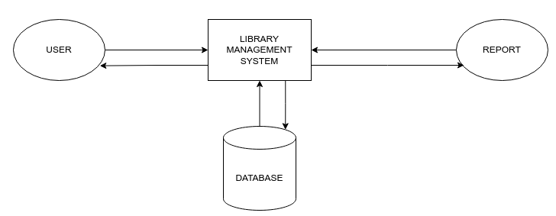

**4.4 REQUREMENT ANALYSIS**

**4.4.1 FUNCTIONAL REQUIREMENTS**

* User and admin Registration and Authentication
* Cataloguing and Classification
* Search and Discovery
* Circulation Management
* User management
* Portfolio of creators
* Register new book

**4.4.2 NON-FUNCTIONAL REQUIREMENTS**

Non-functional requirements of a Library Management System (LMS) define the quality attributes, constraints, and performance characteristics that the system must possess to meet user expectations and adhere to organizational standards. Here are some common non-functional requirements of an LMS:

* **Performance:** The LMS should be responsive and performant, providing fast response times for user interactions such as search, checkout, and navigation. It should also be able to handle concurrent user sessions and heavy loads without significant degradation in performance.
* **Scalability:** The system should be scalable to accommodate growth in the library's collection size, user base, and transaction volume over time. It should be able to scale horizontally by adding additional servers or nodes as needed to support increased demand.
* **Reliability:** The LMS should be reliable and available whenever users need to access library resources or perform system functions. It should have built-in redundancy, failover mechanisms, and backup systems to ensure uninterrupted service and data integrity.
* **Security:** The LMS should be secure and protect sensitive information such as user data, circulation records, and digital resources from unauthorized access, disclosure, or tampering. It should comply with industry standards and best practices for data encryption, access control, and authentication.
* **Usability:** The LMS should be user-friendly and intuitive, with a clear and consistent user interface that minimizes user errors and confusion. It should provide helpful feedback, guidance, and assistance to users as they navigate the system and perform tasks.
* **Accessibility:** The LMS should be accessible to users with disabilities, providing support for assistive technologies such as screen readers, keyboard navigation, and alternative input methods. It should comply with accessibility standards such as WCAG (Web Content Accessibility Guidelines) to ensure equal access for all users.
* **Compatibility:** The LMS should be compatible with a wide range of devices, operating systems, and web browsers to accommodate diverse user preferences and technological environments. It should also support integration with third-party systems and services commonly used in libraries.
* **Maintainability:** The LMS should be easy to maintain and update, with modular architecture, well-documented code, and clear separation of concerns. It should support version control, automated testing, and continuous integration to facilitate ongoing development and maintenance.
* **Compliance:** The LMS should comply with relevant legal and regulatory requirements, such as data protection regulations (e.g., GDPR), copyright laws, and library standards (e.g., MARC formats). It should also adhere to organizational policies and guidelines for information management and security.
* **Performance:** The LMS should meet performance requirements, such as response time, throughput, and availability, under normal and peak loads. Performance testing and optimization should be conducted to ensure that the system performs reliably and efficiently in production environments.

**ER DIAGRAM**

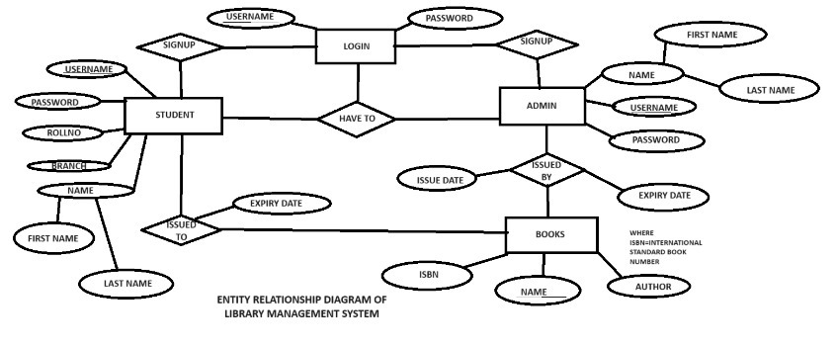

**CHAPTER 5**

**SYSTEM IMPLEMENTATION**

1. **HOME**

A homepage is the main or initial webpage of a website or web application that serves as the entry point for users. Our typically provides an overview of the website's content, login for both user and admin and navigation options, allowing users to easily access different sections or functionalities.

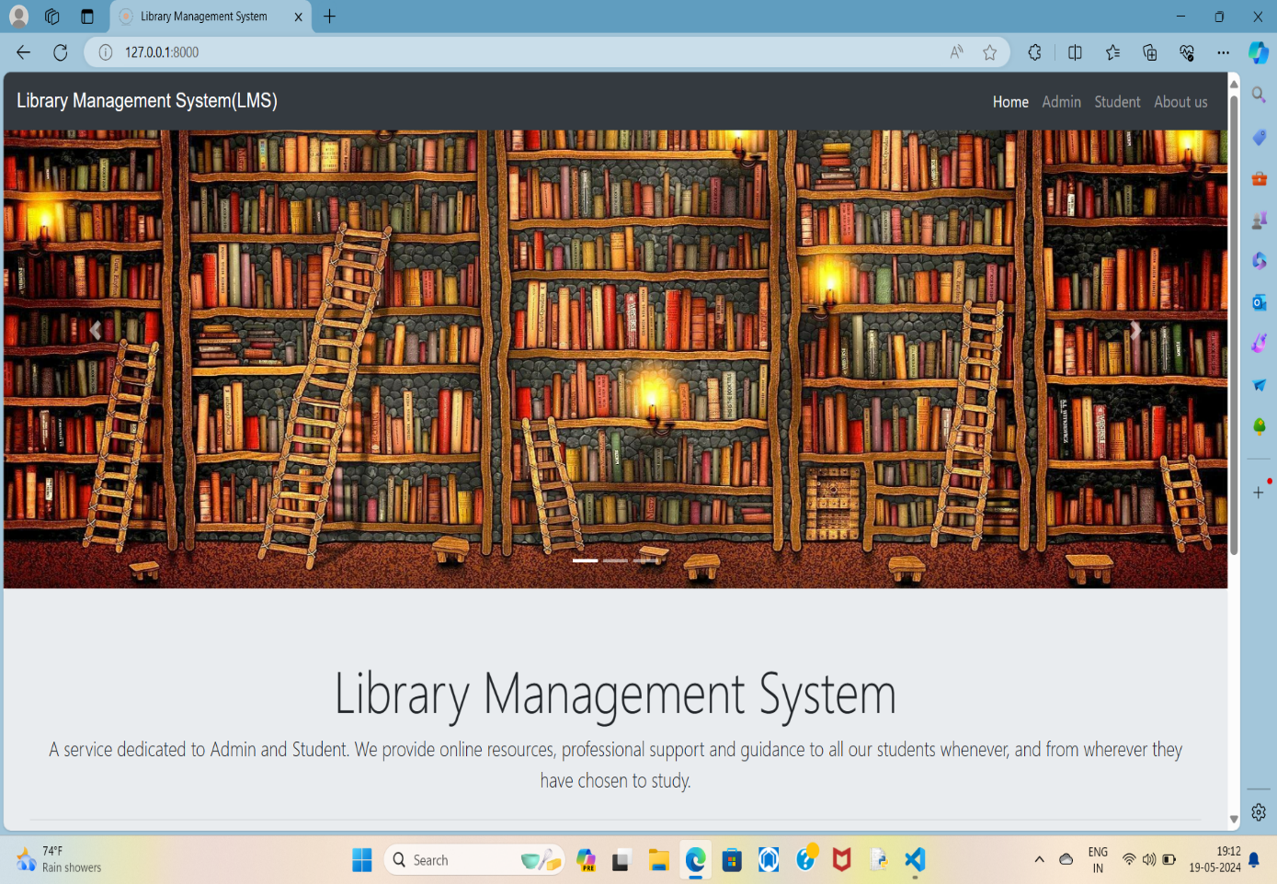

After scrolling the homepage, we will find two tools that navigate us to student login and admin login. This login process is also possible with admin and student options.

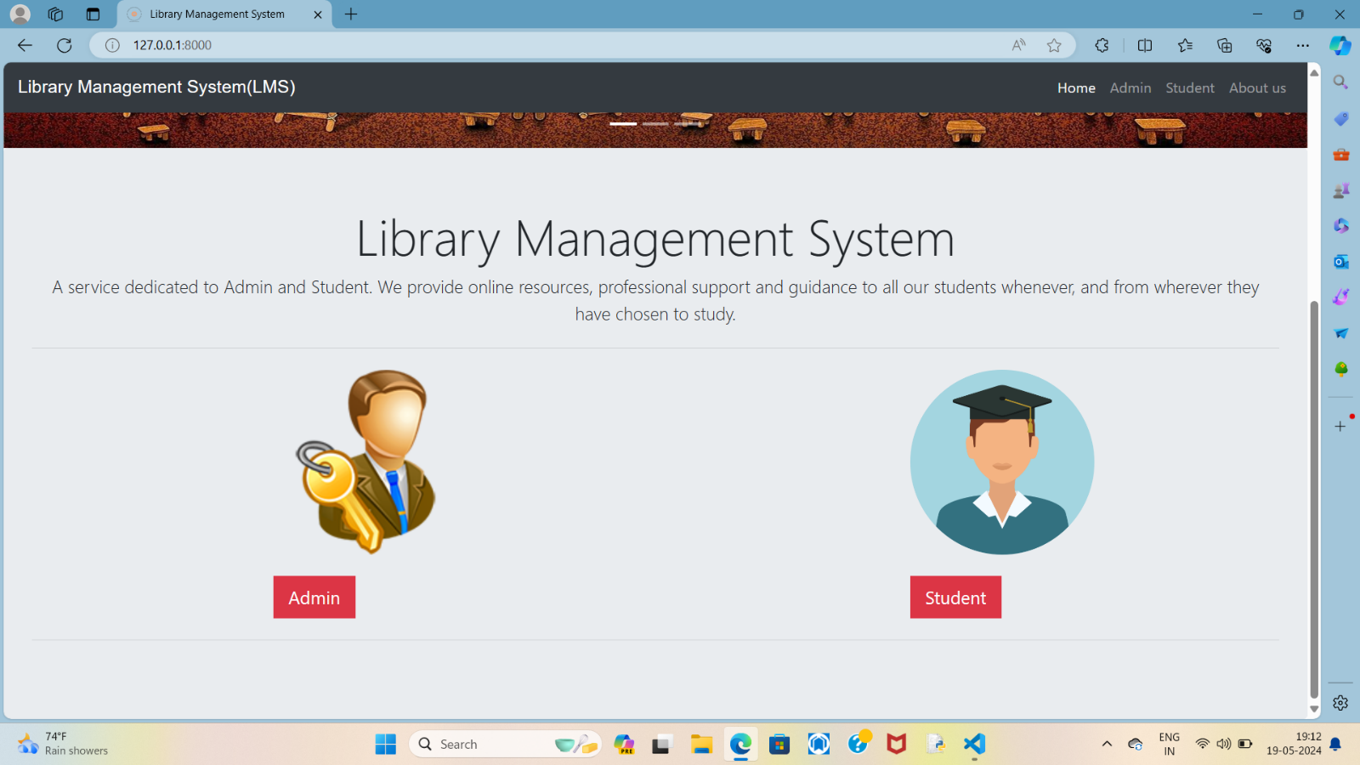

1. **ADMIN**

An admin in an LMS (Learning Management System) typically refers to someone with administrative privileges who oversees and manages the system.

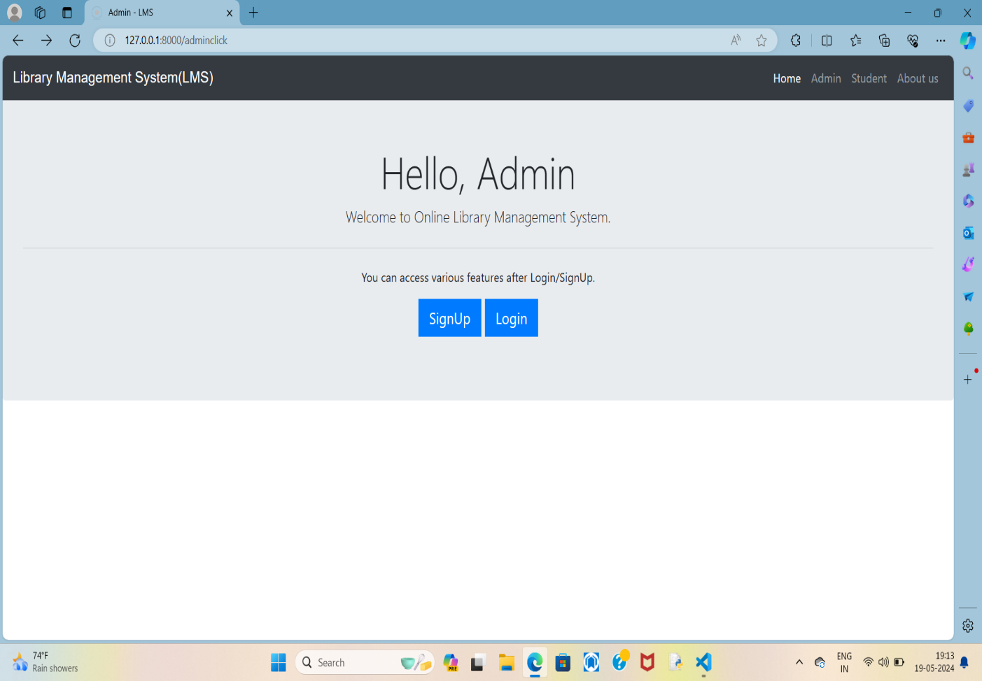

By clicking on the admin icon, the admin will be shown two options,

Login and signup. In case of new admin, he or she should signup. If admin already have account, then he/she can login.

**Admin Signup**

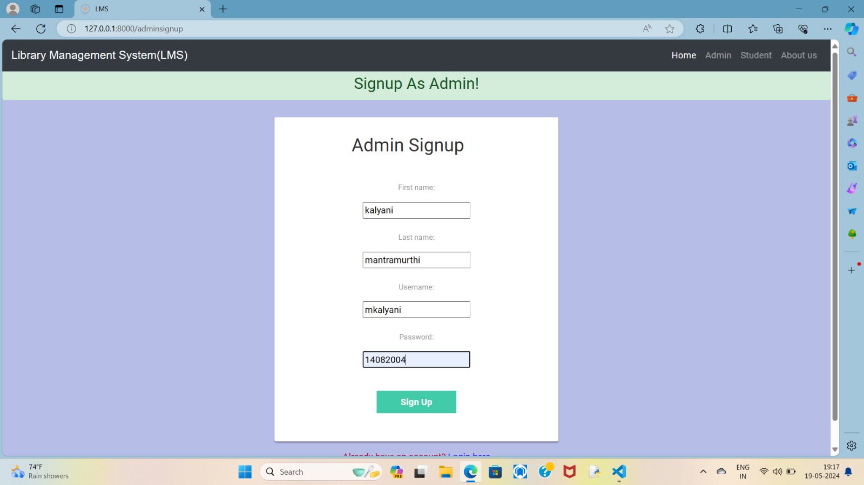

After choosing the signup option the website will be directed towards signup page. Here the admin needs to provide his details and signup. After signup you will directly take to login page.

**Admin login**

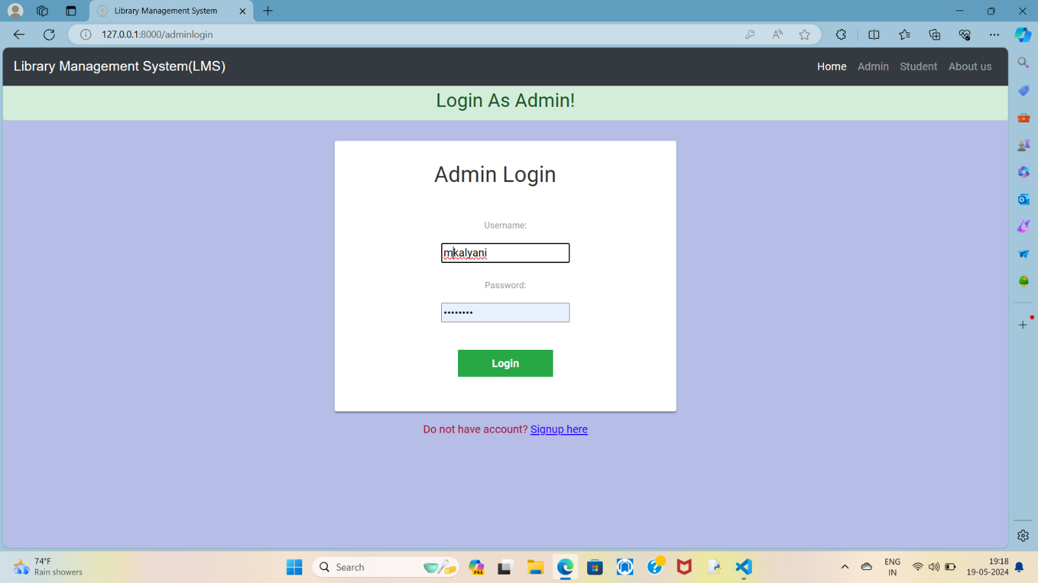

An admin who is already having an account is allowed to login. After logging in the admin is again provided with admin homepage.

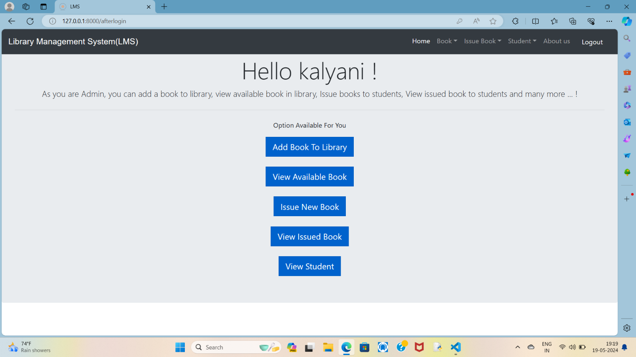

The admin has privileges to issue a book, view all issued books, know all books present and know all the students present.

**ADD BOOK TO LIBRARY**

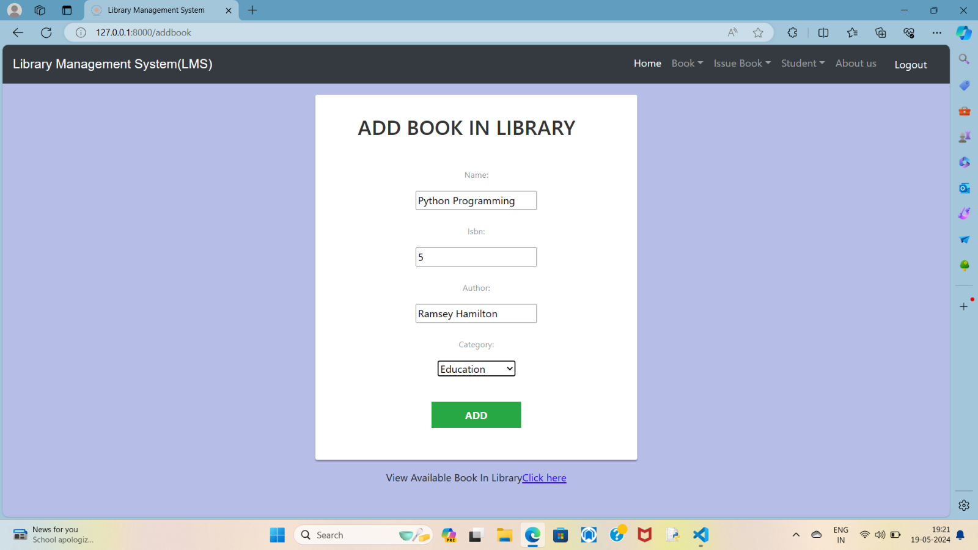

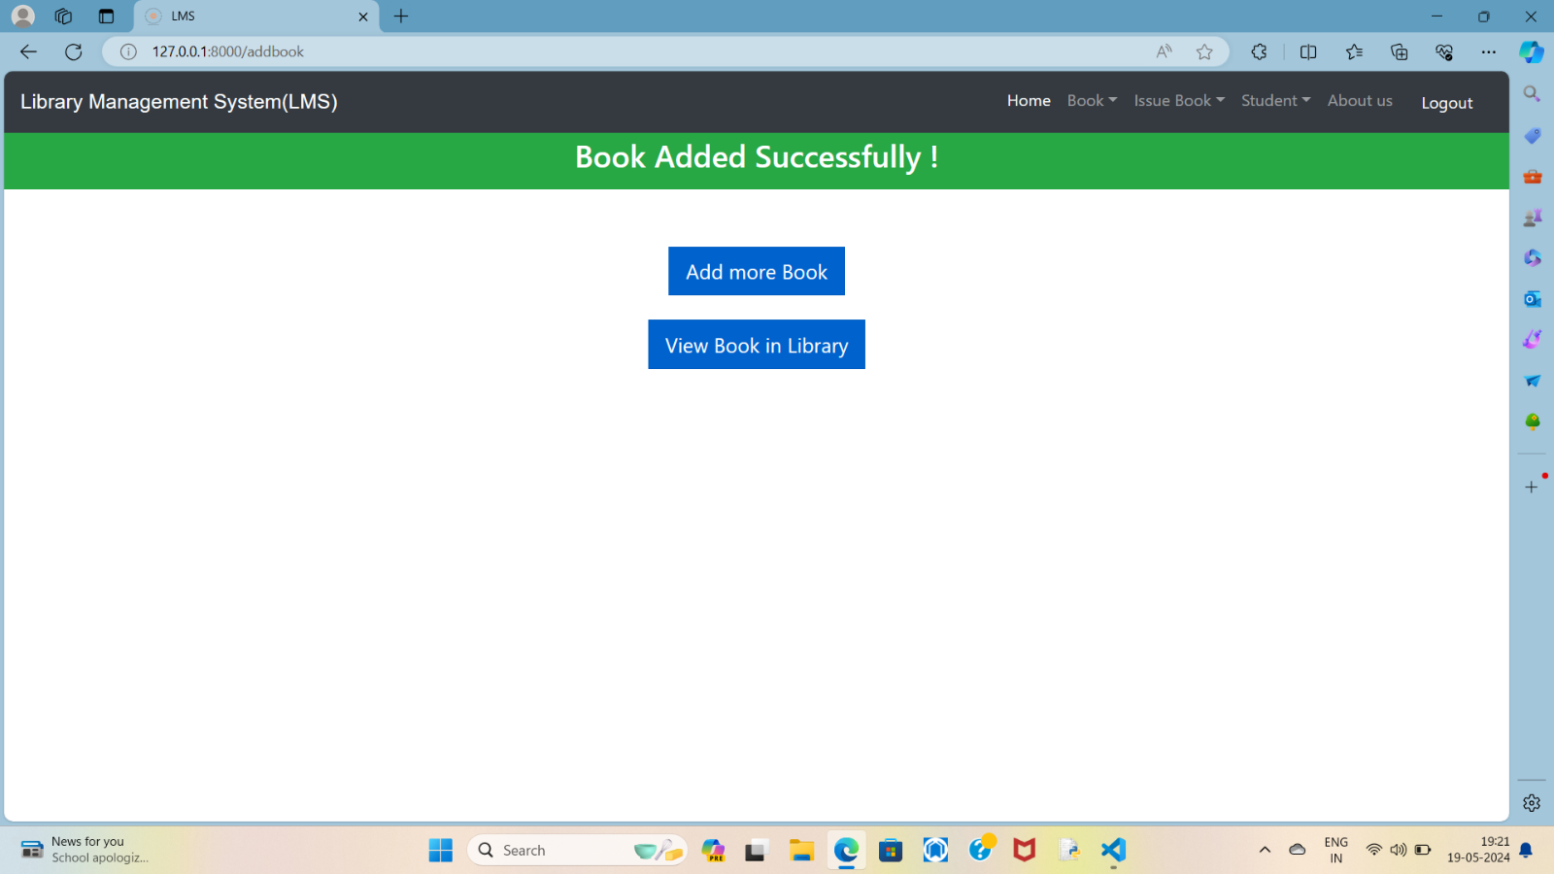

Here by clicking on add more book we can add other books. And by clicking on view book in library we can see the list of books present. we can perform the actions by moving to main also.

**VIEW THE LIST OF BOOKS**

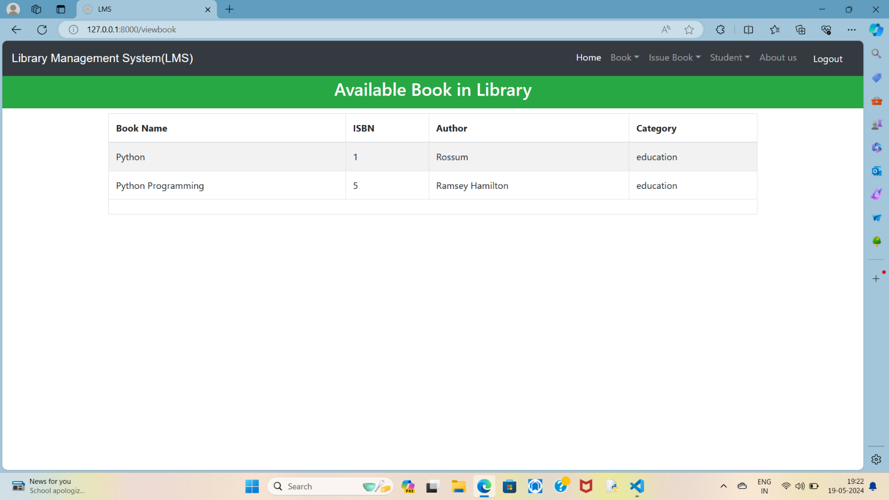

By directing back to admin home admin has privilage to issue a book to student.

**ISSUEING BOOKS TO STUDENTS**

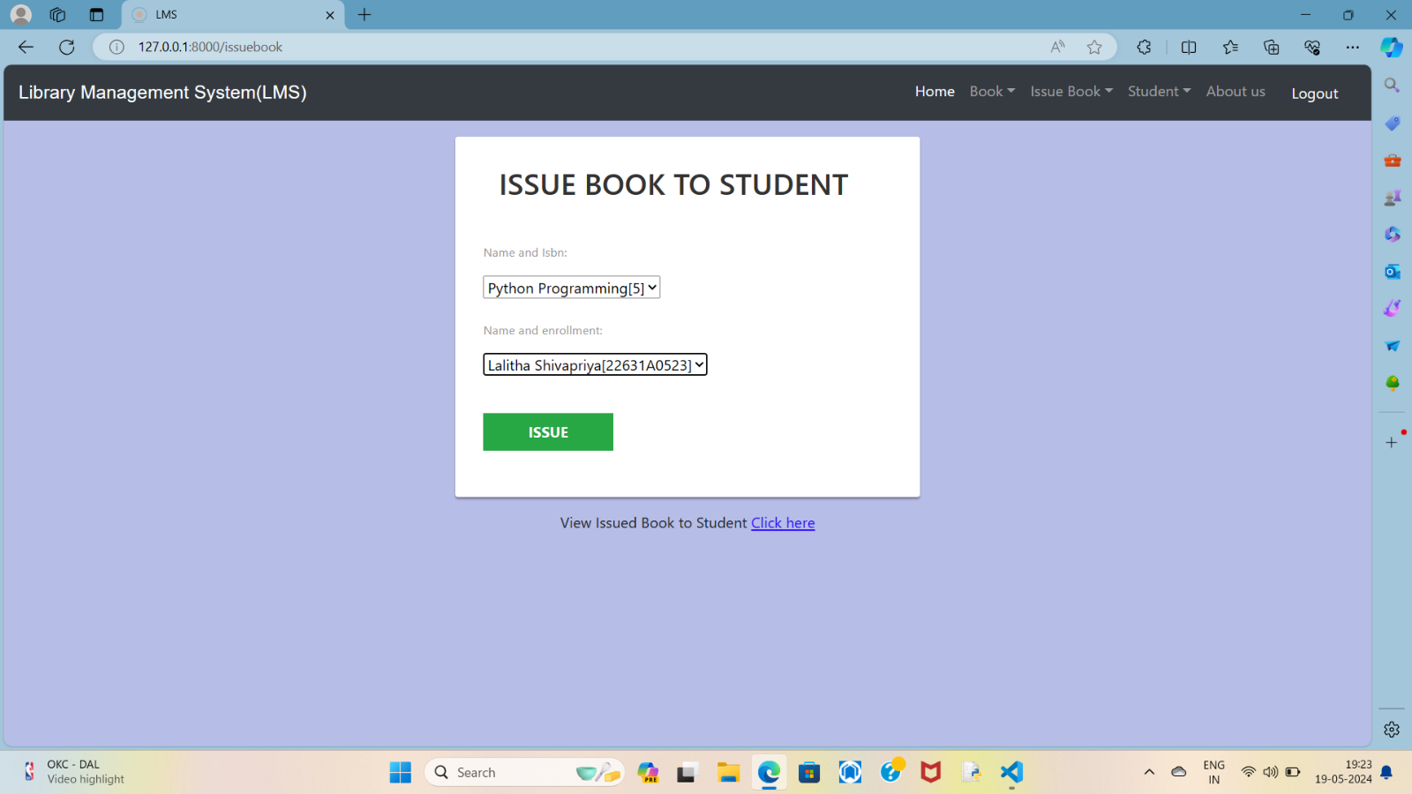

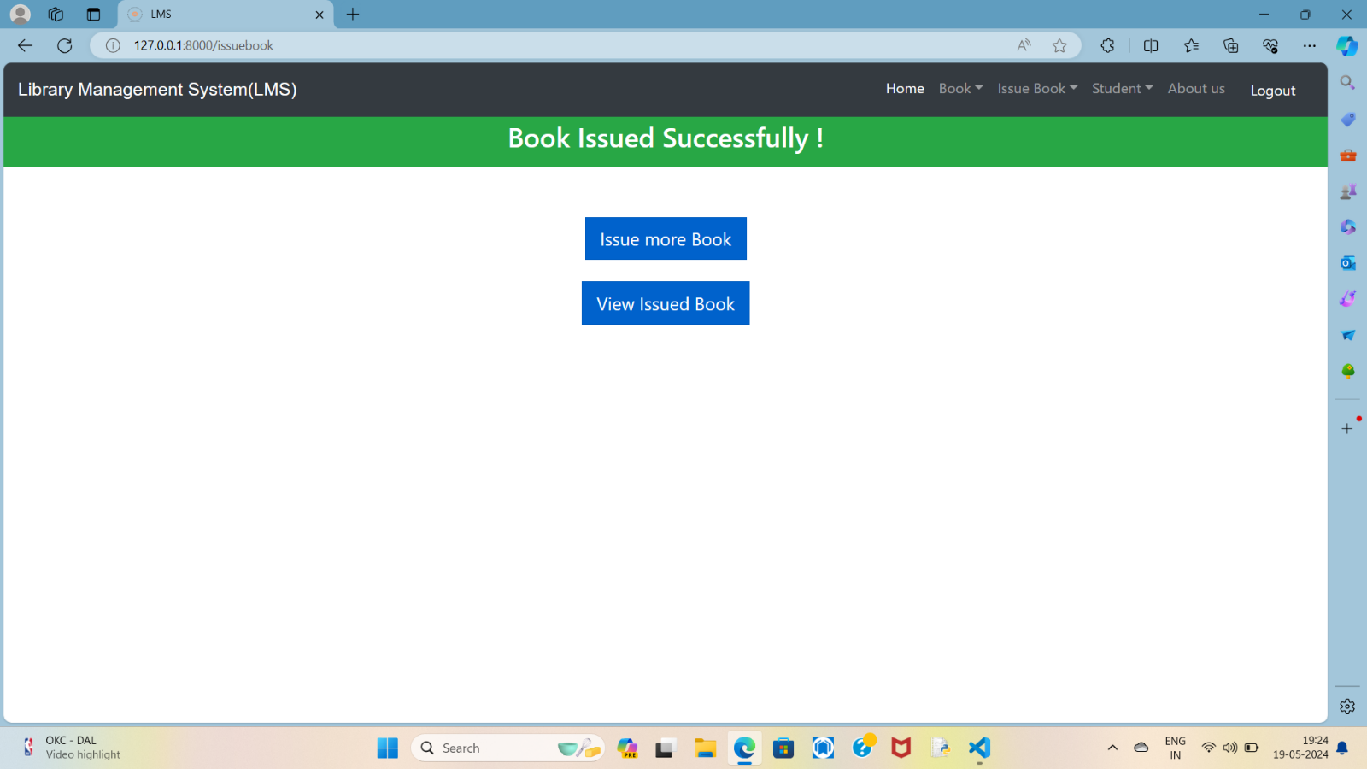

**LIST OF ISSUED BOOKS**

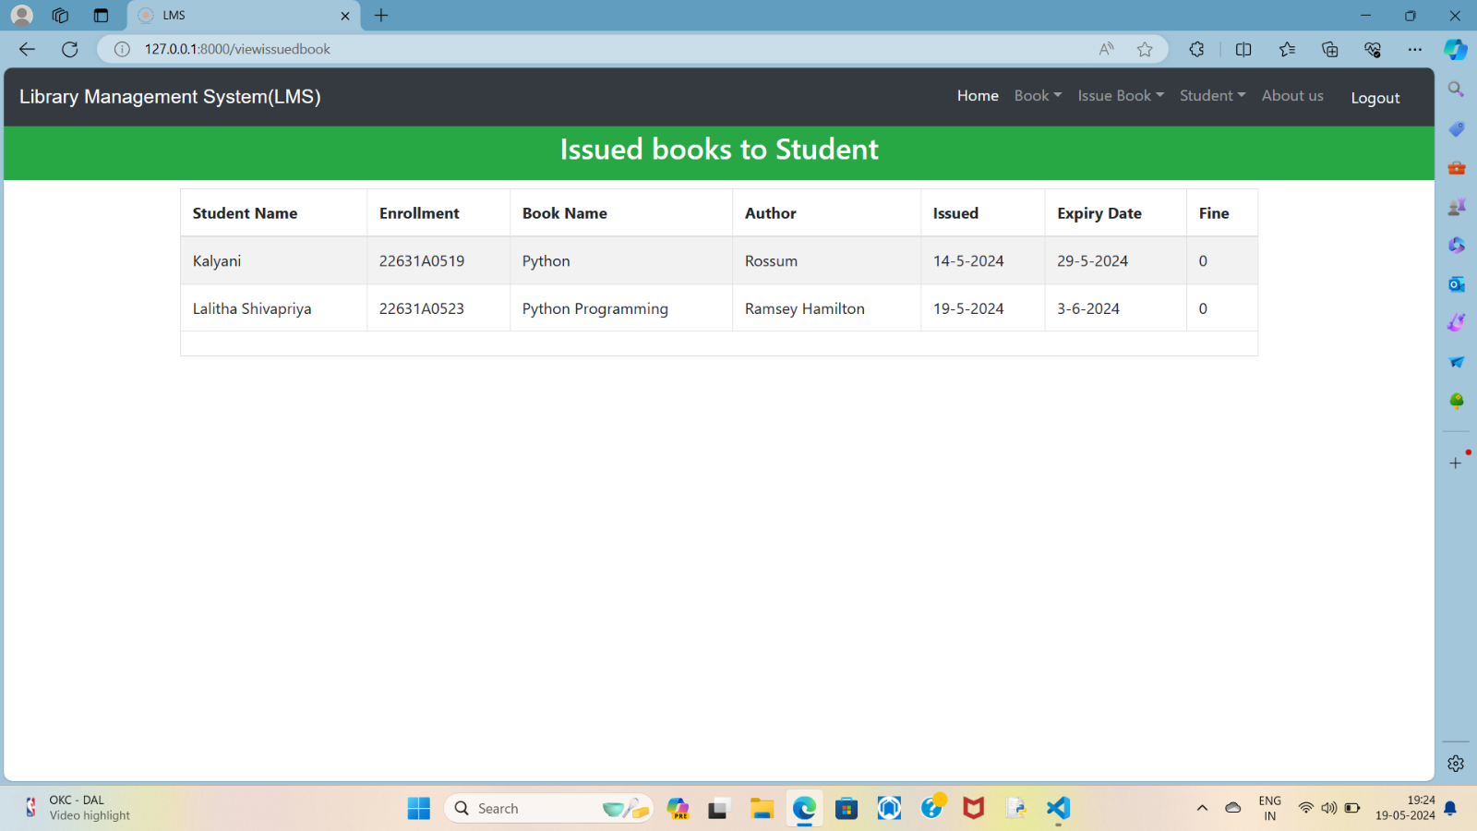

**LIST OF STUDENTS**

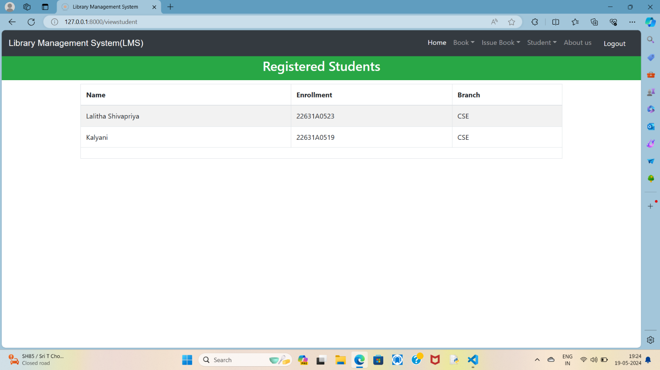

1. **STUDENT**

A student of an LMS (Learning Management System) refers to an individual who uses the platform to engage in reading various books such as Education, Entertainment, Biography

, History, Novel, Fantasy, Thriller, Romance, Sci-Fi.

Student login is different from admin login.

**STUDENT PORTAL**

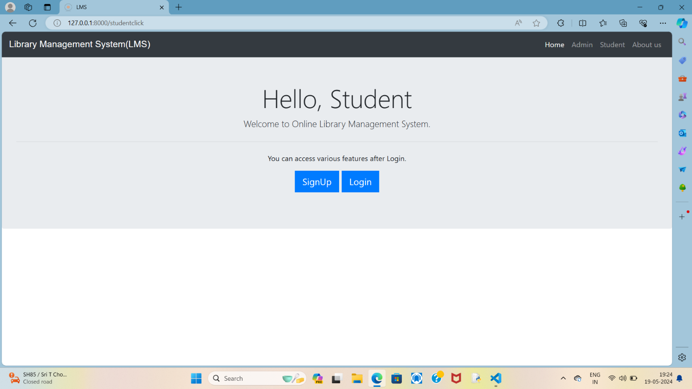

Every new student should signup and already existing student can login.

**STUDENT SIGNUP**

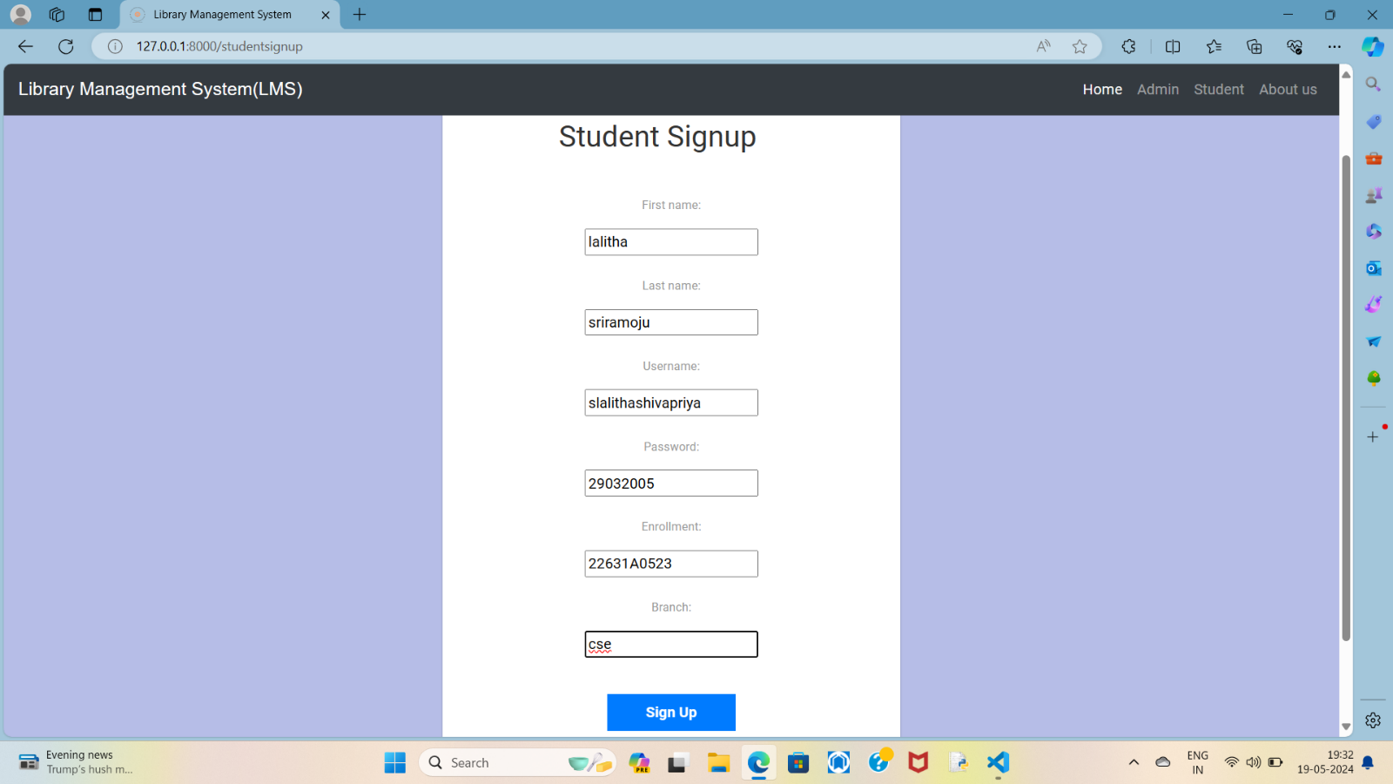

**STUDENT LOGIN**

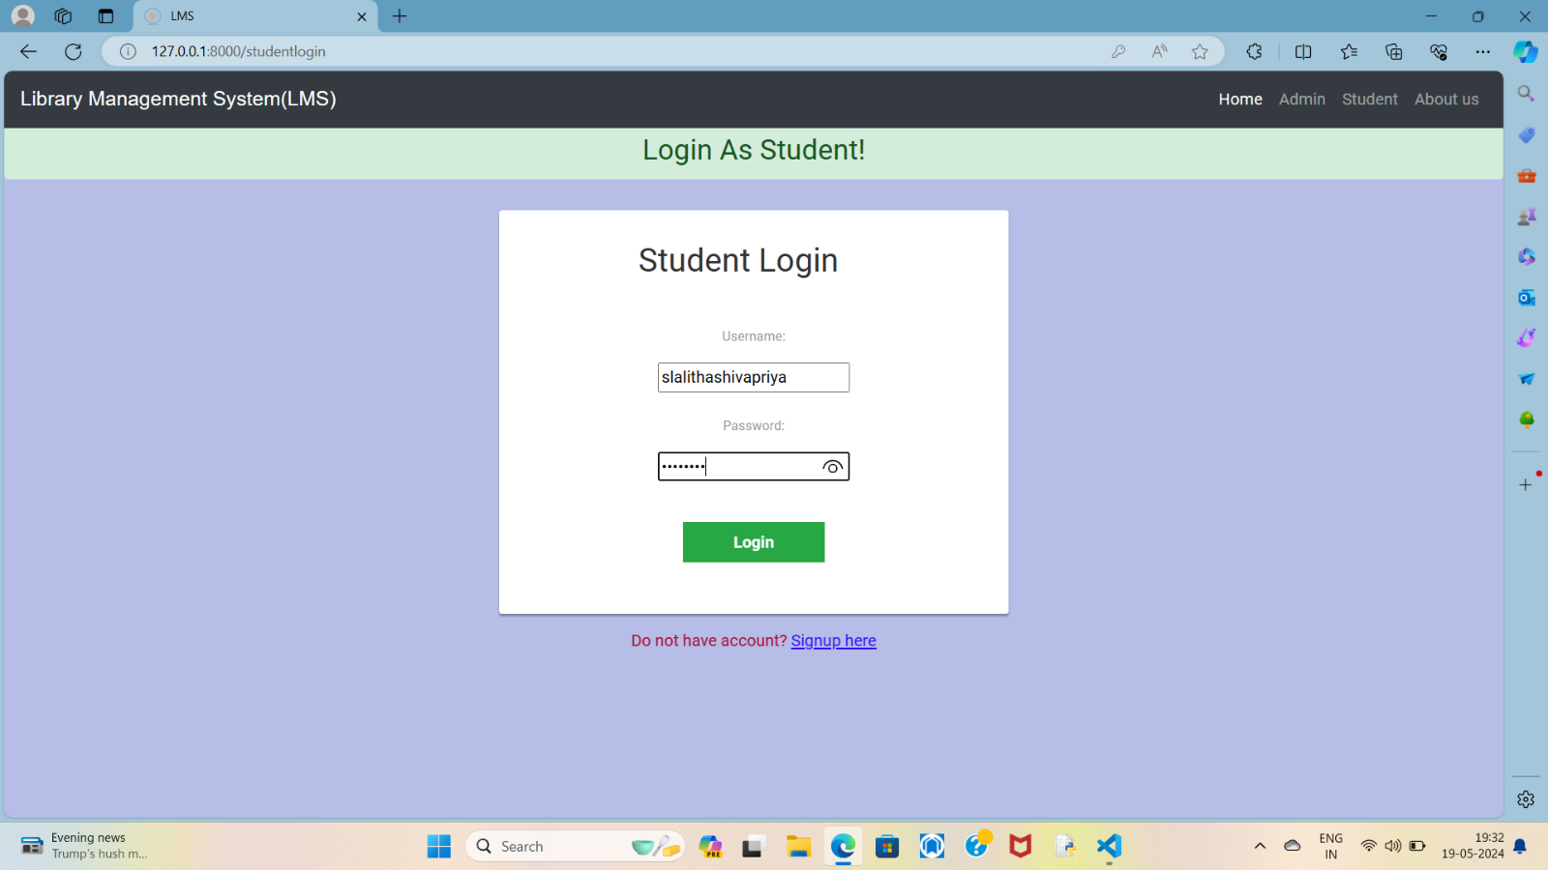

**STUDENT HOMEPAGE**

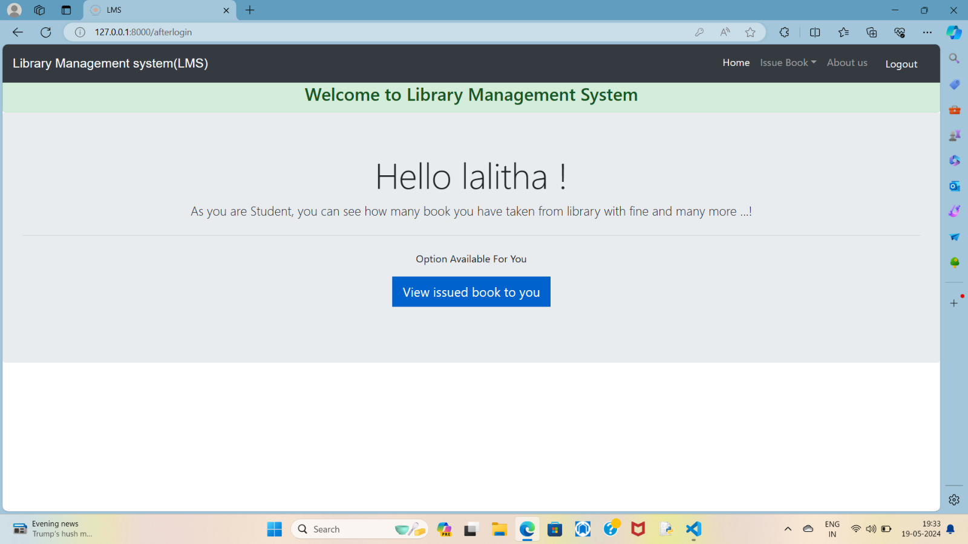

By clicking on view issued book to you, student can see all the books issued to him or her. Students have no privileges like take a book view student like admin. Students have only access to books issued them.

**VIEW ISSUED BOOKS TO YOU**

By simply clicking on logout button in the navigation bar both student and admin can logout of their account.

**BOOK RETURN PAGE**

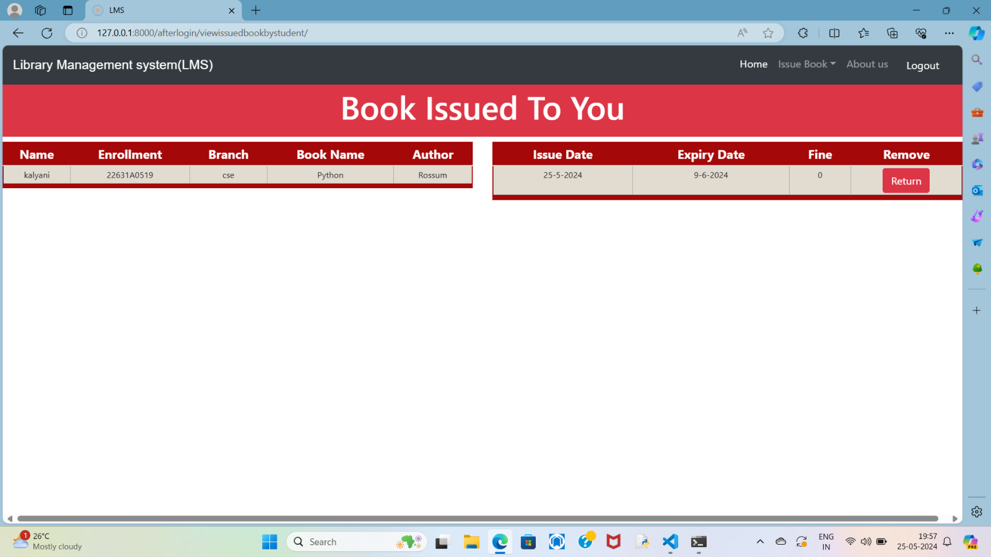

After viewing the issued book the student also have privilage to return book by clicking on the return buton

1. **ABOUT US**

An "About Us" page is a section on a website that provides visitors with information about the organization, company, or individual behind the website. It typically includes details such as the organization's history, mission, values, team members, achievements, and contact information. The purpose of an "About Us" page is to establish credibility, build trust with visitors, and provide insight into the identity and ethos of the entity represented by the website.

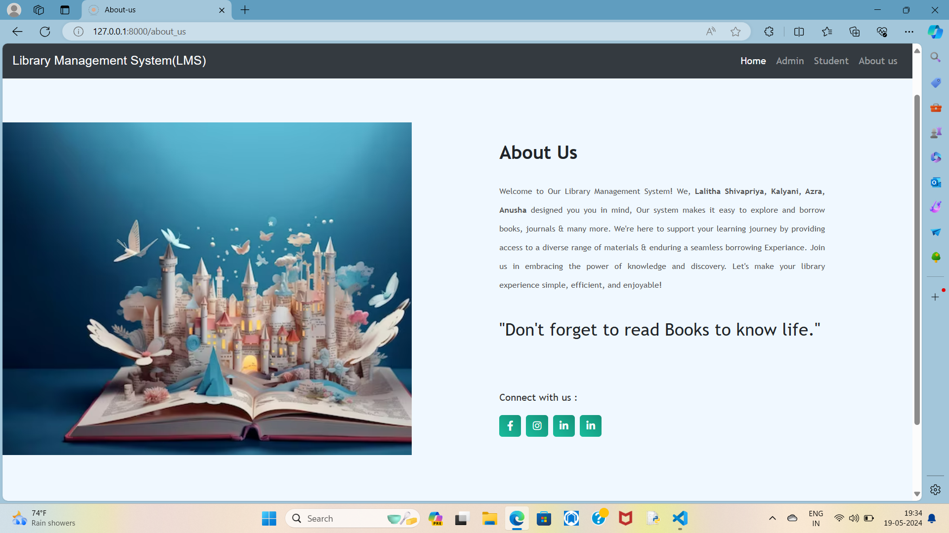

**CHAPTER 6**

**SYSTEM AND DATABASE ANALYSIS**

**Use case diagram**

**DATABASE TABLES**

**Database of Django session**

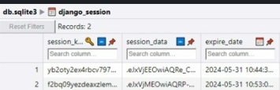

**Library issued book**

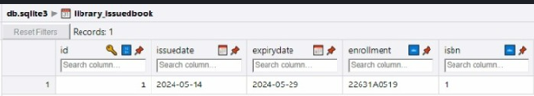

**Django content type**

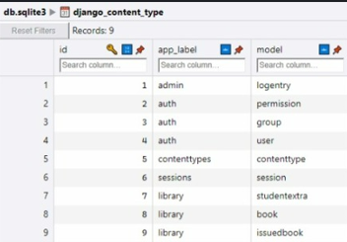

**Auth group**

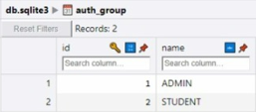

**Auth user**

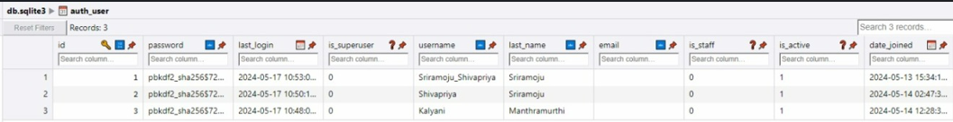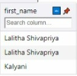

**Library nook**

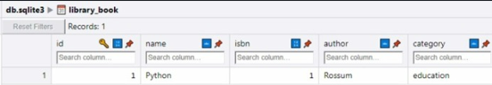

**Library students extra**

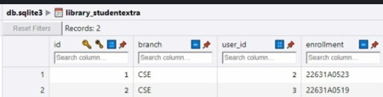

**Types of users and their permissions**

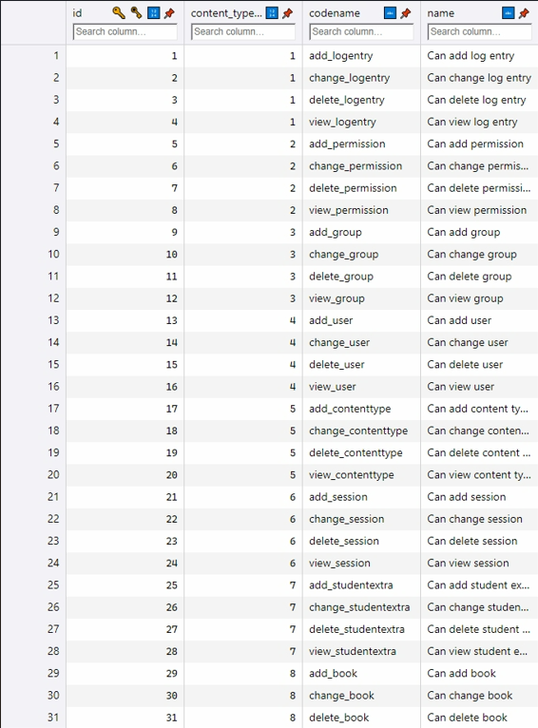

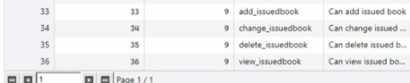

**Django migrations**

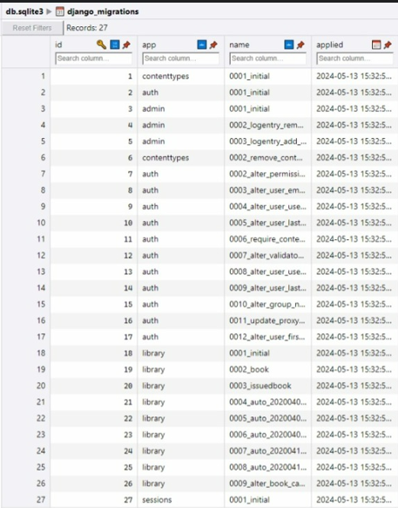

**CHAPTER 7**

**SYSTEM TESTING**

The aim of the system testing process was to determine all defects in our project. The program was subjected to a set of test inputs and various observations were made and based on these observations it will be decided whether the program behaves as expected or not. Our Project went through two levels of testing.

1.Unit testing

2.integration testing

**UNIT TESTING**

Unit testing is undertaken when a module has been created and successfully reviewed. In order to test a single module we need to provide a complete environment i.e., besides the module we would require

* The procedures belonging to other modules that the module under test calls.
* Non local data structures that module accesses .
* A procedure to call the functions of the module under test with appropriate parameters Unit testing was done on each and every module that is described under module description of chapter 4.

1. Test For the admin module

* Testing admin login form-This form is used for log in of administrator of the system. In this we enter the username and password if both are correct administration page will open otherwise if any of data is wrong it will get redirected back to the login page and again ask for username and password.
* Student account addition- In this section the admin can verify student details from student academic info and then only add student details to main library database it contains add and delete buttons if user click add button data will be added to student database and if he clicks delete button the student data will be deleted 37.
* Book Addition- Admin can enter details of book and can add the details to the main book table also he can view the books requests.

1. Test for Student login module

* Test for Student login Form-This form is used for log in of Student. In this we enter the library id, username and password if all these are correct student login page will open otherwise if any of data is wrong it will get redirected back to the login page and again ask for library id, username and password.
* Test for account creation- This form is used for new account creation when student does not fill the form completely it asks again to fill the whole form when he fill the form fully it gets redirected to page which show waiting for conformation message as his data will be only added by administrator after verification.

1. Test for teacher login module- Test for teacher login form- This form is used for logg in of teacher. In this we enter the username and password if all these are correct teacher login page will open otherwise if any of data is wrong it will get redirected back to the login page and again ask for username and password.

**INTEGRATION TESTING**

In this type of testing, we test various integration of the project module by providing the input. The primary objective is to test the module interfaces in order to ensure that no errors are occurring when one module invokes the other module.

**CHAPTER 8**

**CONCLUSION AND FUTURE SCOPE OF PROJECT**

In conclusion, while a Learning Management System (LMS) primarily designed for borrowing books may not offer the extensive features found in traditional educational LMS platforms, it still serves as a valuable tool for managing library resources efficiently. By providing users with a centralized platform to search, request, borrow, and return books, this specialized LMS simplifies the process of accessing library materials and enhances the overall user experience. With features such as online catalogues, reservation systems, and automated reminders, it streamlines library operations and improves accessibility for patrons. While it may not include advanced educational functionalities, such as course creation or assessment tools, a library-focused LMS remains an essential component of any modern library ecosystem, supporting the core mission of facilitating knowledge dissemination and promoting lifelong learning.

The future scope of a library-focused Learning Management System (LMS) extends beyond its current functionality, offering opportunities for enhancement and innovation to meet evolving user needs and technological advancements. Some potential areas of development and expansion include:

1. **Integration with Digital Resources**: As libraries increasingly offer digital collections, the LMS can integrate with various digital platforms and databases to provide seamless access to e-books, journals, databases, and multimedia resources. Implementing features such as federated search, remote access, and digital lending can enhance the breadth and depth of resources available to users.

2. **Enhanced Personalization**: Leveraging data analytics and user profiling, the LMS can personalize recommendations, alerts, and notifications based on users' preferences, search history, and borrowing patterns. By delivering tailored content and suggestions, the LMS can improve user engagement and satisfaction, fostering a more personalized learning experience.

4**. Collaborative Features**: Integrating collaborative tools and social features into the LMS can facilitate knowledge sharing, group discussions, and community engagement among library users. Implementing features such as user forums, ratings, reviews, and sharing options encourages collaboration, peer learning, and knowledge exchange within the library community.

5. **Accessibility and Inclusivity**: Ensuring that the LMS complies with accessibility standards and guidelines enables users with disabilities to access and navigate library resources effectively. Enhancing features such as screen reader compatibility, alternative formats, and assistive technologies promotes inclusivity and ensures equal access to library services for all users.

6. **Innovative Technologies**: Exploring emerging technologies such as artificial intelligence (AI), machine learning, and natural language processing (NLP) can enhance the capabilities and functionalities of the LMS. Implementing AI-powered recommendation systems, chatbots for user assistance, and predictive analytics for resource management can improve user experiences and operational efficiency.

By embracing these future directions and leveraging emerging technologies, a library-focused Learning Management System can evolve into a dynamic and comprehensive platform that enhances access to information, fosters collaboration, and supports lifelong learning in the digital age.

**CHAPTER 9**

**SYSTEM SECURITY MEASURES**

Security of a computer system is a crucial task. It is a process of ensuring confidentiality A system is said to be secure if its resources are used and accessed as intended under all the circumstances, but no system can guarantee absolute security from several of the various threats and unauthorized access.

Security measures will be taken:

• **Strong passwords:**

This first measure is taken that users may use special characters in their passwords and password get strong.

• **Confidentiality:**

If any users are sharing their personal details in login form it will be secure safely as only users can access such information.

• **Hidden Password:**

Whenever user input the password in login form, then password show in * (Asterisk) format.

**CHAPTER 10**

**REFERENCES**

* <http://www.w3schools.com/html/html_intro.asp>
* <http://www.Udemy.com/css/css_background.asp>
* <http://www.w3schools.com/js/js_datatypes.asp>
* [How to Design ER Diagrams for Online Learning Management Systems - GeeksforGeeks](https://www.geeksforgeeks.org/how-to-design-er-diagrams-for-online-learning-management-systems/)
* [ChatGPT](https://chatgpt.com/)

